C258

1. 1. pnorm(200, mean=350, sd=75, lower.tail=TRUE) = 0.02275013
2. pnorm(450, mean=350, sd=75, lower.tail=FALSE) = 0.09121122
3. (1) By hand (cumulative distribution function):
(x-a)/(b-a) = (200-150)/(550-150) = 50/400 = 1/8 = 0.125
By R:
punif(q=200,min=150,max=550) = 0.125
(2) By hand (cumulative distribution function):
1 - ((x-a)/(b-a)) = 1 - ((450-150/550-150)) = 1 - 300/400 = 1 - 3/4 = 1 – 0.75 = 0.25
punif(q=450,min=150,max=550,lower.tail=FALSE) = 0.25
2. 1. 1-pbinom(2,size=5, prob=1/6) = 0.03549383
2. 1-pbinom(0,size=24,prob=1/36) = 0.4914039
1-pbinom(0,size=4,prob=1/6) = 0.5177469
So probability of rolling a dice four times and getting at least one six is marginally higher.
3. small = 1-pbinom(49800,size=100000,prob=1/2)
big = 1-pbinom(50200,size=100000,prob=1/2)
small-big = 0.7940947
3. 1,2 values = rnorm(100, mean=0, sd=1)
qqnorm(values)
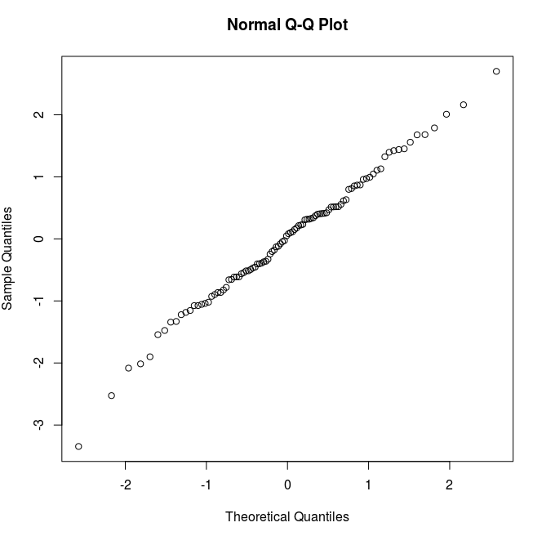

values2 = runif(n=100, min=0, max=1)
qqnorm(values2)

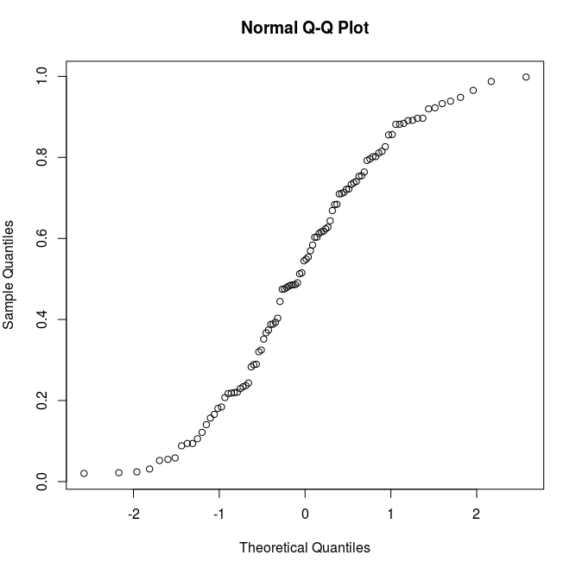

values3 = rt(n=100, df=3)
qqnorm(values3)

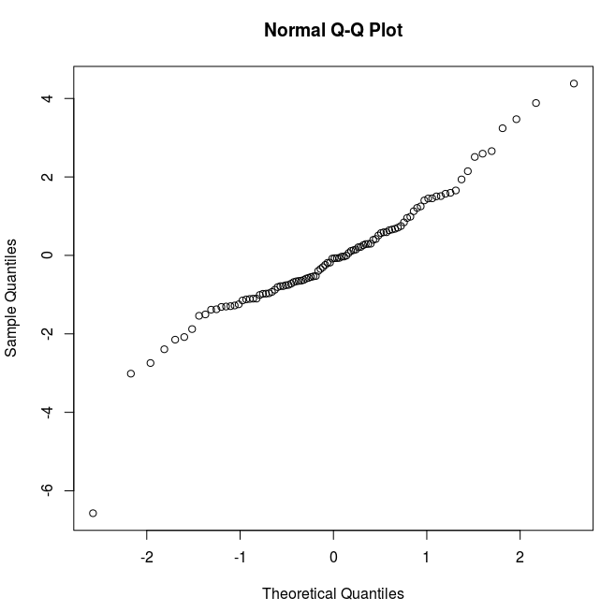

3. The normal distribution curve was close to linear. The uniform distribution had a thin tail on the left and a thick one on the right. The t-distribution with three degrees of freedom is also close to linear, but more flat than the normal distribution curve.

4. 15*180 = 2700
15*25 = 375
pnorm(3500, mean=2700, sd=375, lower.tail=FALSE) = 0.0164487

5. 1. function(n) {
res = c()
for(i in 1:300) {
res[i]=mean(sample(lawsuits, n, replace=TRUE))
}
return(res)
}

2. plot(density(scale(t(5))),xlim=c(-4,4))

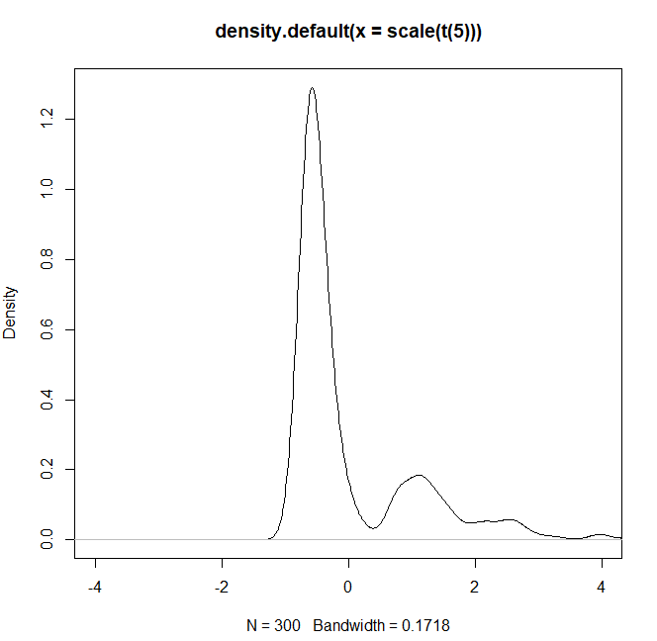

3. lines(density(scale(t(50))), lty=2)
lines(density(scale(t(150))), lty=3)
lines(density(scale(t(350))), lty=5)
lines(density(scale(t(500))), lty=10)

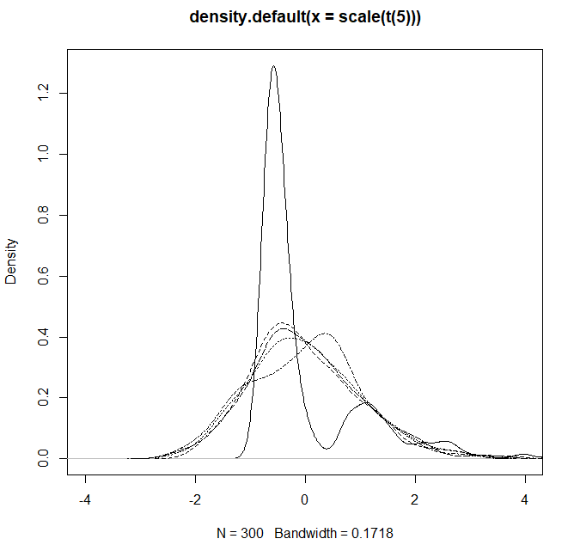

4. n needs to be 50 to achieve bell-shaped sampling distribution.

